EXPERIMENT-02

Aim: Build a simple Hello World Android application. Explore and modify the AndroidManifest.xml file for your application.

Theory:
This practical demonstrates how to create a basic Android application that displays a simple "Hello World" message. It helps understand the structure of an Android app, including activities, layouts, and the AndroidManifest.xml file. It also introduces how UI components are displayed on the screen.

Steps to Create Hello World App
- Open Android Studio
- Click New Project
- Select Empty Activity
- Choose language (Java)
- Click Finish
- Run the application on the emulator

activity_main.xml - This layout file contains a TextView that displays the message “Hello World” on the screen.
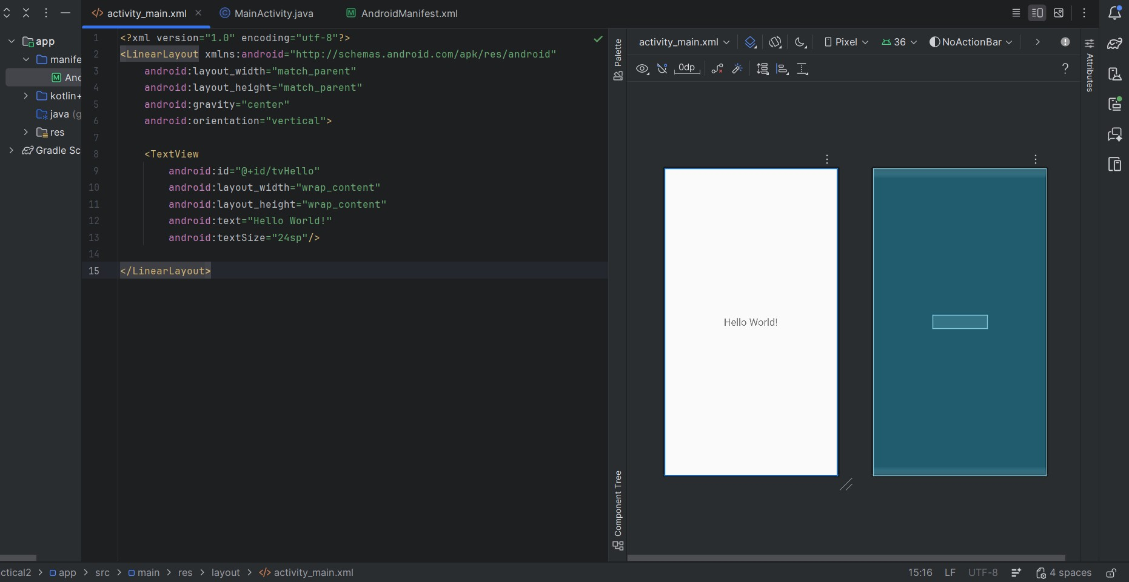

AndroidManifest.xml - The AndroidManifest.xml file contains important configuration details:
- Declares the application package
- Registers activities (MainActivity)
- Defines the launcher activity
- Specifies permissions (if any)
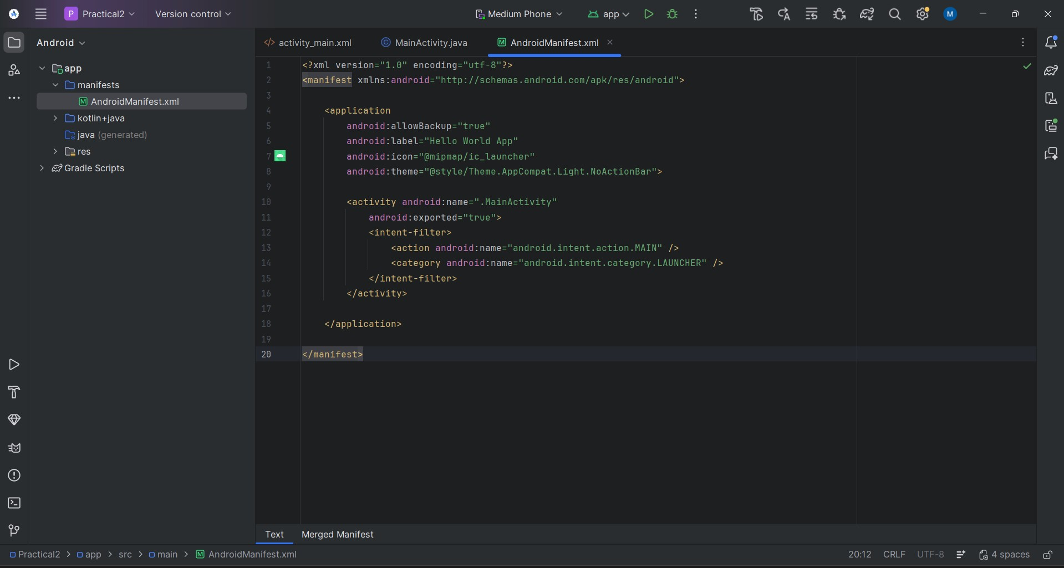

Output:
MainActivity.java - This class is the main entry point of the application. It loads the layout using setContentView() and displays the UI.
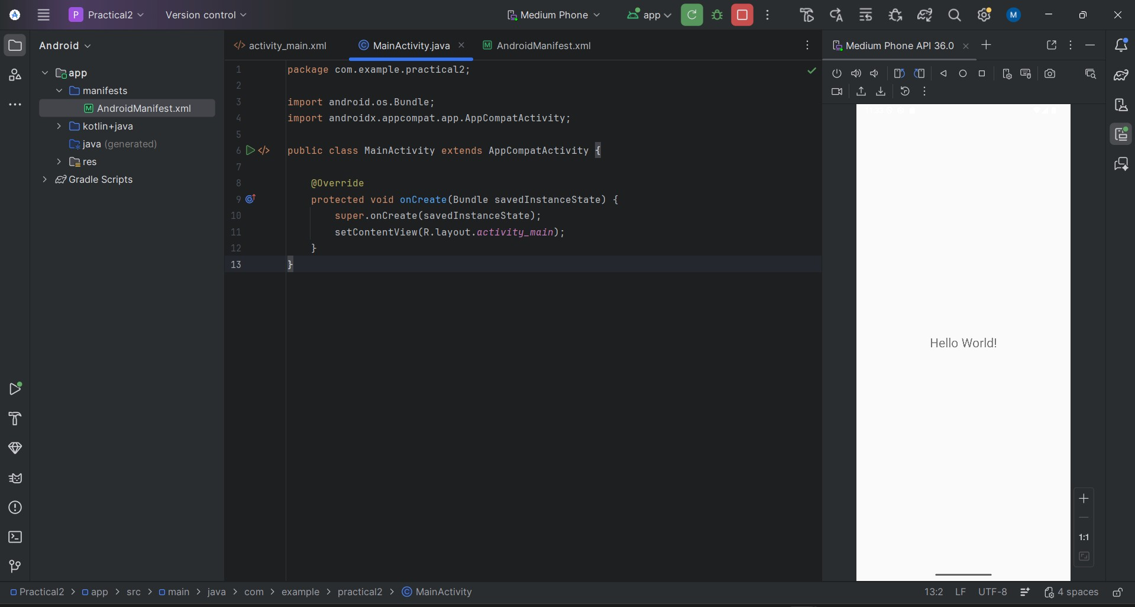

Conclusion:
A basic Android application was developed successfully. The role of AndroidManifest.xml in defining app structure and components was understood.

